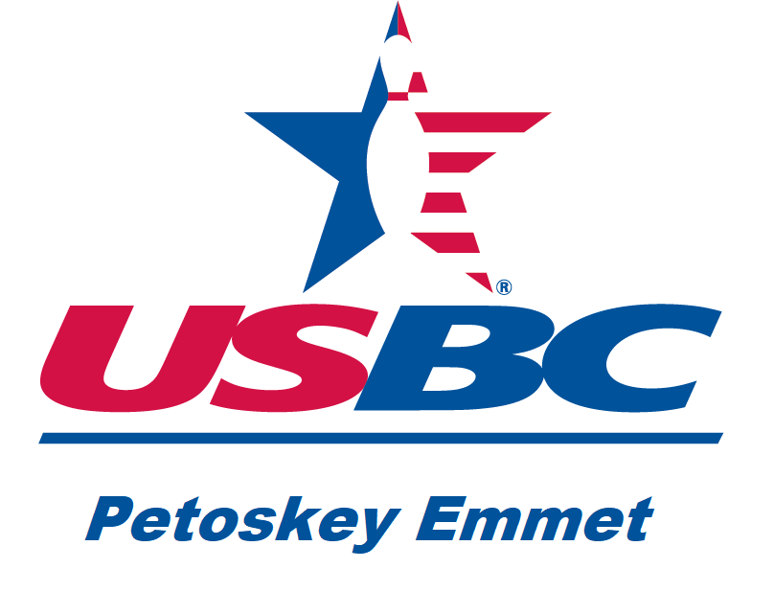
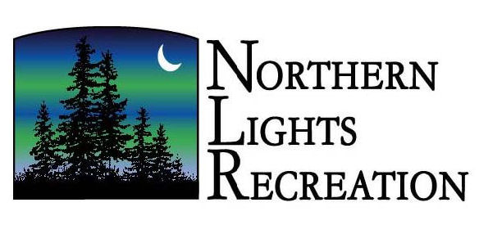
PETOSKEY YOUTH BOWLING
INVITES
All BOYS & GIRLS (Grades 4-12) (School District or Skill Level Does Not Matter)
at
Northern Lights Recreation, Harbor Springs
Monday Evenings 5:20 p.m.–7:30 p.m.
(2-12-week sessions)
Team Bowling Begins
Monday September 30, 2024 through December 16, 2024
January 6, 2025 through March 17, 2025

Warm-ups begin at 5:30 p.m. Sharp!
$10.00/week Includes bowling and shoes for 3-games
Bowl for awards, weekly prizes, or just for fun!

Grab your friends and make a 4-PERSON team (BOYS, GIRLS, OR MIXED) or we can help you find a team
Coaching available (dress codes/rules will be followed)

Sign-up/orientation/instruction: Monday September 9, 2024, 6:00 p.m. at Northern Lights, then give bowling a try for one hour 6:30-7:30 p.m.
for free!

Contact: Deb Hamlin, Coach at hamlin3@sbcglobal.net or 231-203-3608, or
Micki Fedus 231-838-5858

Please call/confirm sign-up, even if you have bowled with us in the past!
Plan on attending our free-session to get re-acquainted and help set up teams or just check it out.

